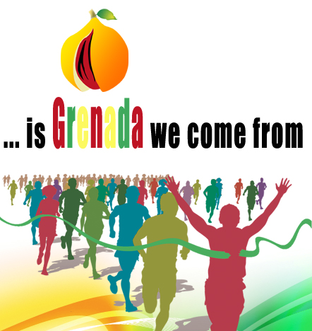

ELEVENTH ANNUAL SPONSORED WALK

IN SUPPORT OF

PRINCESS ALICE HOSPITAL, MIRABEAU, ST. ANDREW

CEDARS HOME FOR ABUSED WOMEN AND THEIR CHILDREN, ST. PATRICK

Five Mile River Thames Walk: Saturday, 28th May 2022.

The walk will cover five miles from Vauxhall to St. Katharine Docks near Tower Bridge.

This year we are supporting two most deserving causes:

Princess Alice Hospital. Located at Mirabeau in St. Andrew’s parish, providing essential health care for residents of St. Andrew’s and neighbouring parishes since 1950.

Suction Machine – Hospital Grade x 1 £400.00
Sphygmomanometer – standing on wheels x 3 £250.00 each
Adjustable medical lamps x 3 £200.00 each

Cedars Home for Abused Women and their Children. Located in St. Patrick’s parish, this is the only facility in Grenada for victims of domestic violence. The home is desperately in need of new kitchen equipment and other essentials.

Every penny we receive in sponsorship will go towards making a real difference for the people served by these two deserving causes, so please subscribe as much as you can in their support.

Please enter your details in the sponsorship form overleaf, and give generously!

************************

Please assemble at the following start point for 10.00 am. The walk will commence at 11:00 am prompt.

The Riverside Bar & Restaurant, Hamilton House, 5 St. George Wharf, Vauxhall, London SW8 2LE.

Buses: 2, 36, 77, 87, 88, 156, 185, 196, 344, 360 and 436.

Tube: Victoria Line.

Overhead trains from Vauxhall have connections to Waterloo, Clapham Junction and Wimbledon etc.

The sequence of bridges we shall be crossing is: Westminster, Hungerford, Millennium, Southwark and ending with Tower Bridge.

The walk will finish at St. Katharine Docks, London E1W 1LA.

Buses: 15, 42 and 78.

Tube: Tower Hill – Central and District Line.

Toprail: Fenchurch Street.

************************

For any further information, please contact the High Commission for Grenada on
020 7385 4415 and office@grenada-highcommission.co.uk or Mrs. Deborah Bryant on:

Mobile: 07956 635 204

Email: grenadafundraising@gmail.com

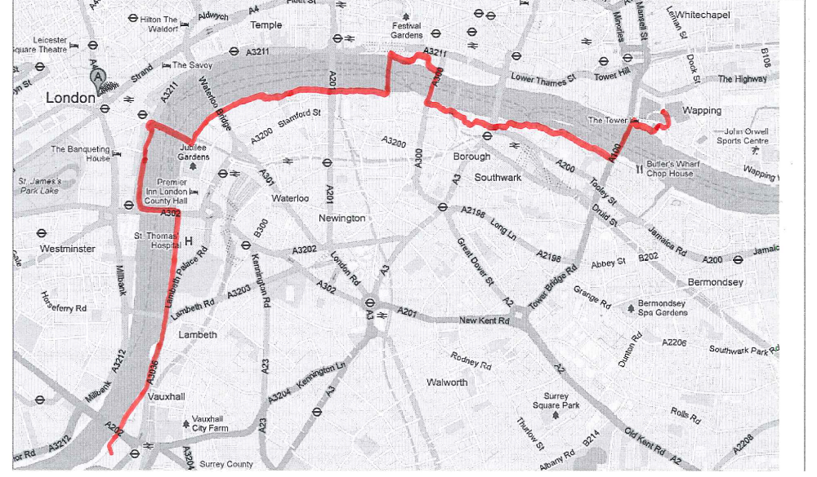

Sequential Bridge Crossings:

Westminster Bridge
Hungerford Bridge
Millennium Bridge
Southwark Bridge
Tower Bridge


ELEVENTH ANNUAL SPONSORED WALK

Name of Walker: ………………………………………………………………………
Event Date: Saturday, 28th May 2022
Details of Event: 5 mile walk from Vauxhall to St. Katharine Docks, E1W 1LA

Name  (Sponsor) | Contact Details  Address / Telephone Number / Email Address | Amount Pledged | Amount  Paid
Please make cheques payable to: Grenada Fundraising |  |  | Total:

This is to confirm that ……………………………….……………… has successfully completed the five mile River Thames Walk on Saturday, 28th May 2022.

(signed) …………………………………..….. (date) ……………………………………..
Deborah Bryant (Event organizer).

